PCB changes

In order to allow the LEDs to function properly, two minor modifications have to be made.

1) Add a 390 ohm resistor between the GPIO04 output of the ESP8266 EFP-12 and the data input of LED1.

2) Add a 470 pf capacitor between the data input of LED1 and ground.

# The components

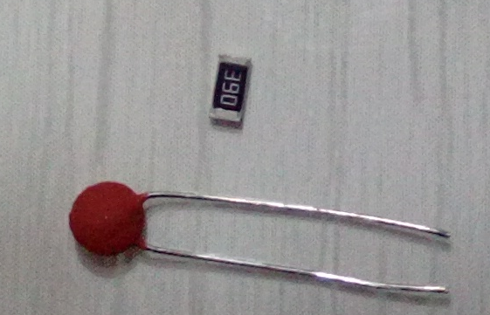

# Cut the track

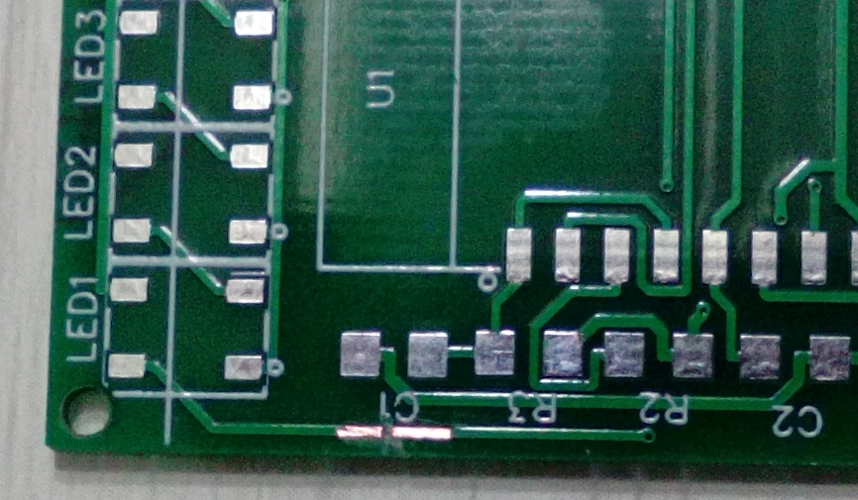

# Weld the resistance

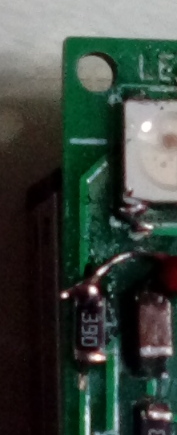

# Weld the condensator

